CHAPTER FIVE NITRIFICATION
by
G.A. Ekama and G.v.R. Marais

- INTRODUCTION

The term nitrification describes the biological process whereby free and saline ammonia is oxidized to nitrite and nitrate. Nitrification is mediated by specific autotrophic organisms with behavioural characteristics that differ significantly from the heterotrophic ones. The objectives in this chapter are to review briefly the kinetics of nitrification, to highlight the factors that in­ fluence this biological reaction and set out the pro­ cedure for designing a nitrifying-aerobic activated sludge process.
It has been well established that nitrification is due to two specific genera of autotrophic bacteria, the Nitrosomonas and Nitrobacter. Nitrification takes place in two sequential oxidation steps: (1) Nitrosomonas convert free and saline ammonia to nitrite, and (2) Nitro­ bacter convert nitrite to nitrate. The nitrifiers utilize am­ monia for their synthesis nitrogen requirements, and as a source of energy to bring about synthesis. The am­ monia requirement for synthesis, however, is a negligi­ ble fraction of the total ammonia processed by the organisms, at the most 2% (van Haandel and Marais, 1981). Consequently it is usual to neglect the metabolic nitrogen requirements* of the nitrifiers and to consider the nitrifiers simply to act as catalysts for the ammonia­ nitrite-nitrate reactions - the reactions are taken as stoichiometric. This greatly simplifies the description of the kinetics of the process.
Consider the two basic redox reactions in nitrifica­
tion,
NH₄⁺ + 3/2 0₂ (Nitrosomonas) - NO₂⁻ + H₂0 + 2H⁺
(5.1a)

- BIOLOGICAL KINETICS
  - Growth
'\
In order to formulate the nitrification b'ehaviour it is necessary to understand the basic biological growth kinetics of nitrification. Here one has to con.sider the two stage nitrification behaviour. The rate of conversion of ammonia to nitrate, by the Nitrosomonas is much slower than that of nitrite to nitrate, by the Nitrobacter. In fact, under most circumstances in municipal waste­ water treatment plants, any nitrite that is formed is con­ verted virtually immediately to nitrate. As a conse­ quence very little nitrite is observed in the effluent from a plant operating on an influent that does not contain substances that inhibit the Nitrobacter. The limiting rate in the nitrification sequence, therefore, is that due to the Nitrosomonas - one needs to consider the kinetics of this organism only. Because the nitrite produced is virtually immediately converted to nitrate in terms of the growth rate of the Nitrosomonas, it can be assumed that the conversion is from ammonia to nitrate directly - on this basis the kinetics of nitrification reduce to the kinetics of the Nitrosomonas.
Experimental investigations by Downing, Painter and Knowles (1964) showed that the nitrification rate can be formulated in terms of Monad's relationship. Monod found that: (1) The mass of organisms generated js a fixed fraction of the mass of substrate (in this case ammonia) utilized. (2) The specific rate of growth, that is, the rate of growth per unit mass of organisms per unit time, is related to the concentration of substrate surrounding the organisms.

N0i + 1 /2 0₂ (Nitrobacter) – NO₃ (5.1b)

Stoichiometrically the oxygen requirements for the first and second reactions are 3,43 and 1,14 mg0/mgN [also written as mg0/mg(NH₃-N)]. Hence the conversion of ammonia to nitrate, both expressed as N, requires 4,57

From (1):
M(ΔXn) = Y_{n} M(ΔNa) where

(5.2)

mg0/mgN utilized. Taking into account the ammonia utilized for metabolic purposes of the nitrifiers, the oxygen requirements per mg(NH₃-N) processed are slightly less, with reported values down to 4,3 mg0/mg (NH₃-N). However, such a sophisticated approach is more of academic than practical interest and we will ac­ cept the stoichiometric value, 4,57 mg0/mg(NH₃-N).
M(ΔXn) = mass of nitrifiers generated, (mgVSS)
M(ΔN_{a}) = mass of ammonia as N utilized, [mg(NH₃-N)]
Yn = mass of nitrifiers generated per' unit mass of ammonia utilized, [mgX_{n}/ mg(NH₃-N)]

*In nitrification processes, where the influent energy source consists principally of ammonia, this simplification no longer can be applied and the determination of the nitrifying sludge mass is necessary to design the process volume (Neytzel-de Wilde, 1977). With municipal wastes under
)1 cyclic flow conditions the nitrifying mass also needs to be calculated.

5-1

Consequently, one can write
dX_{n}/ dt = Y_{n} * dN_{a}/ dt

(5.3)
Nn = nitrate concentration, (mg(NO₃-N)/ J).
The oxygen consumption associated with nitrifica­ tion is based on the stoichiometric assumption mentioned

From (2) Monod developed the following relation­ ship:
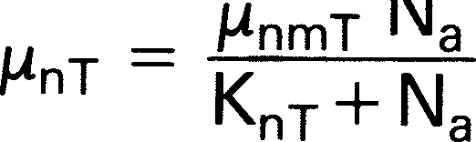 (5.4)
where
µn = specific growth rate observed at concentration Na, (mgXn/ mgXn/d)
µnm= maximum specific growth rate possible (mgXn/ mgXn/ d)
Kn = half saturation constant, i.e. the concentra­ tion at which µn =½ µnm, [mg(NH₃-N)/£]
Na = concentration of ammonia surrounding the organisms, [mg(NH₃-N)/1]
earlier, i.e. conversion of 1 mg(NH₃-N) to 1 mg(NO₃-N) requires 4,57 mgO. Consequently
dOn = 4 57dNa (5.11)
dt ' dt

  - Endogenous respiration

Up to this stage attention has been focussed on the growth aspect. However, Herbert (1958) showed that generally an organism mass undergoes a continuous mass loss, called endogenous mass loss. Furthermore from the great amount of research undertaken by the Marais group it seems that this loss occurs in­ dependently of the growth. This allows straightforward formulation of endogenous mass loss as,

T subscript refers to temperature, °C
ddtXn-_
-b nTX n (5.12)

The growth rate is given by the product of the specific growth rate and the organism mass
where
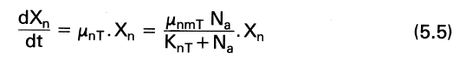

Instead of expressing the growth rate in terms of the mass of organisms, it is often useful also to express it in terms of the depletion rate of ammonia, as follows:
From Eq. 5.3 substituting for dXn/dt in Eq. 5.5

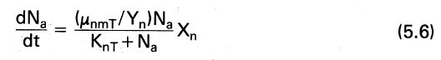
Equation 5.6 is sometimes written in an equivalent form as follows: Define the maximum specific substrate utilization rate, KmT = µnmT/Yn then the specific substrate utilization rate KT becomes from Eq. 5.4
K _ K_{mT} N_{a} (5 7)
T- K_{nT}+N_{a} .
and the rate of substrate utilization, from Eq. 5.6
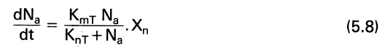
bnT = specific endogenous mass loss rate for
Nitrosomonas (mg/mg/d)

  - Behavioural Characteristics

In Figure 5.1 the relationship between the specific growth rate, µn, the specific substrate utilization rate, K, and the substrate concentration, Na is shown, as described by Monod's equation Eqs. 5.4and 5.7 respectively. The rate
constants selected are µnm20=0,33, Yn =0, 10 (hence Km= 3,3) and Kn20 = 1,0. The interesting feature of this
plot is that, because Kn is so small 1 mg(NH₃-N)/ L, the specific rate is virtually at a maximum for concentrations of 2 mg(NH₃-N)/ 1 and higher. However at concentra­ tions less than two the rate rapidly declines to zero so that the ammonia is not readily reduced to zero.

3·
PROCESS KINETICS

This form is mentioned here because it is the one often used to express heterotrophic growth, and in fact is the form utilized in all the work published by the Marais group, because of its greater convenience for some purposes. The point to note is that Eqs. 5.6 and 5.8 are of equal merit.

The ammonia nitrogen that disappears in the nitrification reaction, reappears as nitrate nitrogen because the stoichiometric approach is adopted, i.e.
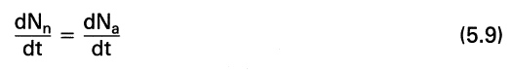
Consequently
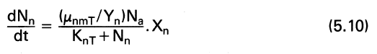

As indicated in Chapter 4 the basic process unit is the completely mixed activated sludge unit. The process under steady state provides the information necessary for design.
With regard to nitrification, for design, the principal
steady state solution required is that of the effluent am­ monia concentration from a completely mixed aerobic reactor. This solution forms the basis for extensive analysis of the process behaviour. A comprehensive analysis is not required here; for those interested reference should be made to Ekama, van Haandel and

Marais (1979) and van Haandel and Marais (1981).

  - Effluent ammonia concentration

Consider nitrification in a completely mixed reactor,
where
(5.10) under constant flow and load conditions (see Figure 4.1). A mass balance on the accumulation of nitrifier mass M(AXn) is given by

5-2

FIGURE 5.1: Monod's relationship for nitrification at 20°C.

M(8Xnl = VP 8Xn = [µnmT· Na/(Knr+ Nal] .Xn. Vp M
- bnT · Xn. Vp. M - Xn. q. M
where
VP= process volume(£)
q = volumetric withdrawal rate of waste sludge
from the reactor (f/d)
Dividing by VP M
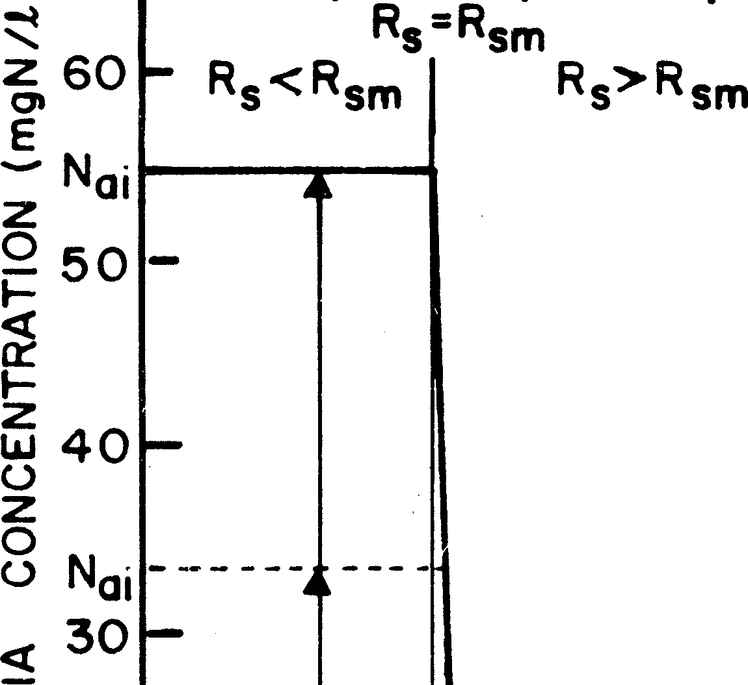
8Xn/ M = [µnmT Na/ ( Knr + Nal]Xn - bnr Xn - Xn q/V p Now
VP Xn _ Mass of nitrifier sludge in process = R q Xn Mass of nitrifier sludge wasted per day q s
where
Rs = sludge age (d) (see Eq. 4.2).
Under constant flow and load, when steady state is achieved, 8Xn/ M = 0 and solving for Na yields,

ing Nai for Na in Eq. 5.13 and solving for Rs gives the minimum sludge age, Rsm, below which theoretically, no nitrification can be achieved. This minimum sludge age varies slightly with the magnitude of Nai, see Figure
5.2 - higher Nai gives a slightly lower Rsm· Now the ef­ fective influent Nai (see later) will rarely be less than about 20 mg/£. Noting that Knr 1 mgN/£, then

N = knr!bnr+1/Rs)
a µnmr-(bnr+1/Rsl

(5.13)

It is of interest to note that in Eq. 5.13 the ammonia concentration (Nal in the reactor (and effluent) is in­ dependent of the specific yield constant (Ynl and the in­ fluent ammonia concentration (Nail. Using the same nitrification kinetic constants as those in Figure 5.1 and taking bnr=0,0, a plot of Eq. 5.13with Na versus sludge age Rs is given in Figure 5.2. Note that at long sludge ages Na is very low and remains so until the sludge age is lowered to about 3,5 days below which, Na increases rapidly until, in terms of this equation, Na can exceed the influent concentration, Nai - evidently the limit of application of the equation is when Na= Nai· Substitut-

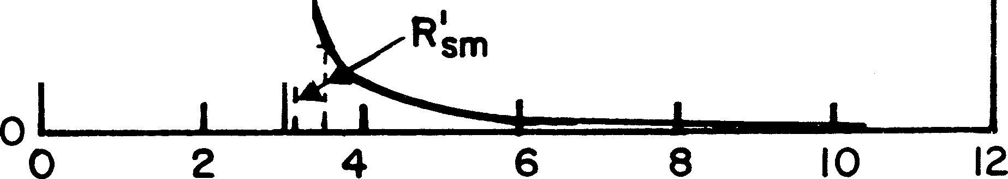SLUDGE AGE ( days)
Data from Downing !! (1964)
Yn = 0,05 mgVSS/mgN
.Unm = 0,33 /d Kn = 1,0 mgN/t
at 20°c
0
z
Cl)
w
::!!:
I-
:::>
::!!: 20
:::> IJ..I ...J
cnZ
<t
a-:.:..J
o:::>
,Unm Na
Kn+ Na
I.I..
Iz-
·a
z
:::>
IJ..I
10
R m '!' Rsm
I.I.. N.
01
...J
--- _ _l-- -
I

FIGURE 5.2: Relationship between sludge age for nitrification and influent ammonia concentration, Na;,

5-3

KnT/N8; is negligibly small _ with respect t_o unity. Substituting zero for KnT/N8; in Eq 5.13 and solving for Rsm• yields
 (5.14)
For practical application, Eq. 5.14 adequately defines the minimum sludge age for all Na; greater than about 5 mgN/£.
The virtually constant value for Rsm (for the ac­ cepted values of µnmT and bnT) and the rapid attainment of high nitrification efficiency at sludge ages slightly greater than Rsm causes that in a particular plant, as the sludge age is increased, once Rs exceeds Rsm, high effi­ ciency of nitrification will be observed. Consequently, under steady state conditions one would expect a plant either not to nitrify, or, to nitrify with high efficiency
With regard to bn₂₀; this value empirically is taken as constant for all waste flows, at bn₂₀=0,04/d. Its ef­ fect is small so that there is no need to enquire closely into all the factors affecting it.
With regard to KnT little information on effects of inhibitory agents is available; very likely KnT will increase with inhibition.

  - Temperature

The µnm and Kn constants are sensitive to temperature with a high temperature coefficient (see Eq. 5.15); semi­ empirically bnT is taken also to have temperature dependency at the same rate as that for heterotrophs (see Eq. 5.16).

depending on whether Rs is shorter or longer than Rsm respectively. This behaviour is well attested by observa­ tion on laboratory scale plants.
From the discussion above clearly the magnitudes
µnmT = µnmzo(1, 123)(T-ZO)
KnT = Kn20(1,123)ff-ZOl bnT = bn20( 1,029)ff-ZO)
(5.15a)
(5.15b)
(5.16)

of µnmT and bnT affect Rsm; it is of importance, therefore,
for practical application, to enquire into those factors that influence these constants and the nitrification phenomena in general.

/
- FACTORS INFLUENCING NITRIFICATION

A number of factors affect the nitrification rate con­ stants, efficiency of nitrification and the maximum sludge age. These are (1) wastewater source, (2) temperature, (3) pH, (4) unaerated zones, (5) dissolved oxygen concentration, and (6) cyclic flow and load.

  - Influent source

The maximum specific growth rate constant µnmT has been observed to be specific to the source of the waste flow and, even then, to vary between different batches from the same source. This specificity is so marked that µnmT should be classified as a wastewater characteristic. The effect appears to be of an inhibitory nature due to some substance(s) in the wastewater. It is not toxicity because high efficiency of nitrification can be achieved even with a low µnm value if the sludge age is increased sufficiently. These inhibitory substances are more likely to be present in effluents having some industrial waste components and in general, the higher this fraction, the lower µnmT tends to be, but the specific waste fractions that cause the reduction of µnmT have not been clearly delineated. Taking the µnmT value at 20°C as the reference value, µnm₂o values have been reported rang­ ing from 0,33 to 0,65 per day. These two limits will have a significant effect on the minimum sludge age: Two plants, having these respective µnm2o values, will have
R values differing by hundred per cent. Clearly due to the link between the waste flow and µnmT, th e I atter, s
sm
value should always be estimated experimentally for op­
timal design. In the absence of such a measurement, a low value for µnmT necessarily will need to be selected which, for a particular waste flow, should the actual µnm be higher, will result in a non-optimal design. An ex­
The effect of temperature on µnmT is particularly dramatic, for every 6°C drop in temperature the µnmT value will halve which means that the minimum sludge age for nitrification will double. Design of plants for nitrification, therefore, should be based on the minimum expected process temperature. Note that the temperature sensitivity of KnT does not affect the minimum sludge age, but it does affect the efficiency of nitrification - the higher the Kn the higher also the ef­ fluent ammonia at Rs» Rsm (See Section 4.3).

  - pH and Alkalinity

The specific growth rate of the nitrifiers µn is extremely sensitive to the pH of the culture medium. It seems that the activities* of both the hydrogen and hydroxyl ions,
(W) and (OH-), act inhibitorily when their respective concentrations increase unduly. This happens when the pH increases above 8,5 [increasing (OH-)] or decreases below 7 [increasing (W)]; optimal nitrification rates are
expected for 7 < pH < 8,5 with sharp declines outside
this range.
From Eq. 5.4, µn is a function of both µnm and Kn. From an analysis of Eq. 5.13 it was shown earlier that the minimum sludge age is dominated by the magnitude of µnmT; it is only very weakly influenced by KnT· At Rs
>> Rsm however, the effluent ammonia concentration (N ), although low, is relatively speaking, significantly hi her for larger KnT values: For example if KnT in­ creases by a factor of two, the effluent ammonia con­ centration will increase correspondingly by the same factor (see Eq 5.13). Consequently the value of KnT is significant in so far as it controls the effluent ammonia concentration at Rs>> Rsm·

With regard to experimental estimates of µnmT and Knr, a great amount of research has gone into tracing the effect pH has on µnmT· These investigations general­ ly have not separated out the effects of µnmT and Knr so that most data are in effect lumped parameter estimates of µnmT· Almost no information is available on the effect
of pH on Knr· The effect of pH on Knr can be surmised from data obtained in a laboratory scale completely mix-

perimental procedure to determine µnm2o is given in Ap­

pendix 3.
*Equivalent to concentration.

5-4

FIGURE 5.3: Relationship between TKN and nitrate concentra­ tions and pH with sludge age in an activated plant treating weakly buffered influent sewage from the Strand-Somerset West area, Cape.

ed reactor aerobic activated sludge investigation on a waste flow from Somerset West in the Cape Province. The plant was operated at 20°C over a range of sludge ages from 2 to 30 days. The response of the plant in terms of pH, filtered effluent TKN and nitrate plus nitrite is shown in Figure 5.3. Concomitantly with nitrificatic;m the pH declined, stabilizing at about 4 when the sludge age exceeded· 15 days. The TKN stabilized at
10 mgN/ J.. Up to 10 days sludge age, the pH and nitrate
concentration fluctuated in a see-saw fashion. The fact
For 7,2 <pH< 8,5,
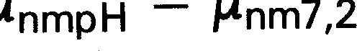

For 5 <pH< 7,2,
µnmpH = µnm7,2 <l>ns(pH·7•21 where
<l>ns = pH sensitivity coefficient
2,35.

(5.17a)

(5.17b)

that stable nitrification was achieved only at 10 days sludge age when the pH was low, indicated that µnmT had decreased to a concomitantly low value. The fact that the effluent TKN ( ammonia) stabilized at the high value of 10 mg/ J. indicated that KnT had increased. On controlling the pH at 7,0 nitrification commenced at
about 3 days sludge age and the effluent TKN ( am­ monia) stabilized at about 4 mg/ J. for R5 > 3 days.
Evidently the pH and µnm reacted interactively so that the minimum sludge age would fluctuate with the pH and achieve stability only at the long sludge age of 10 to 15 days. Evidently also the KnT value is increased at low pH values. Due to the lack of information it is difficult to model quantitatively the effect of pH on µnmT and KnT·
In Figure 5.4 the predictions, using Eq. 5.17 are compared with experimental data on µnm collected by Malan and Gouws (1966). This comparison is illustrative only as it is not clear from the data of Malan and Gouws whether the effect of pH on Kn was taken into account when calculating µnmpH•
Changes in the value of Kn with pH are not at all
documented in the literature. The best than can be done is to accept a dependency on pH and check the predic­ tions against ammonia effluent concentrations reported at the different pH values. On this basis the following equations are suggested,
For 7,2 <pH< 8,5

The following analysis, based on various data sources and empirical assumptions on the behaviour, demon­ strates the general expected trends even though the predicted values cannot be taken as quantitatively cor­ rect. Accepting that µnm remains constant for 7,2 < pH
< 8,5 and decreases as the pH decreases below 7,2
KnpH = Kn7,2 For 5 <pH< 7,2
KnpH = Kn7 2,
where

<I>ns(7,2-pH)
(5.18a)

(5.18b)

(Downing et al. 1964, Loveless and Painter, 1968) this behaviour can be modelled as follows:
<l>ns = pH sensitivity coefficient
2,35.

5-5

100
E 80
C
Although Eq. 5.19 is qualitative in prediction only, it serves an important function in illustrating the adverse effects that temperature and pH can have on µn: A plot of µnTpH is shown in Figure 5.5 for selected values of pH and temperature accepting µnm2o(7,2l = 0,33/d and
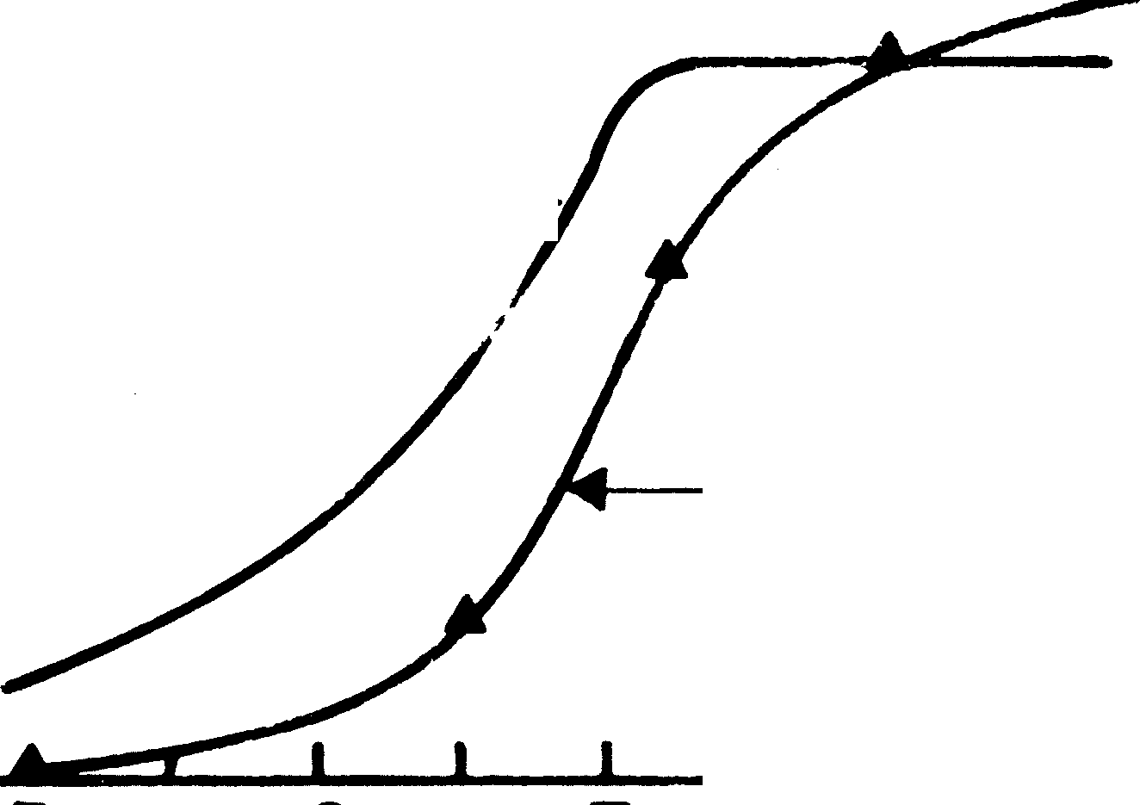Kn2o(7,2)=1,00 mgN/£. Clearly low pH and low

THEORETICAL ►
MODEL

MALAN 8 GOUWS
( 1966}

:::2._ 60
.... ₄₀
z
temperature can have significant effects on design.
In design the temperature effects have to be ac­ cepted as restrictions imposed by the environment.

LuIJ
a::
20
With regard to the effects of low pH, these may, or may
not, occur depending on the alkalinity of the influent.

LaI.J. 0

5 6 7 8 9
MIXED LIQUOR pH
Low influent Alkalinity is likely to give rise to low pH in the purely aerobic activated sludge process. However, it is possible to limit, or completely obviate, pH reduction

FIGURE 5.4: Relationship between maximum specific growth rate for Nitrosomonas, µnm, and mixed liquor pH. Experimental data after Malan and Gouws (1966).

The overall effect of pH or 5 < pH < 7,2 and temperature on µn can be modelled by substituting Eqs. 5.15, 5.17 and 5.18 into Eq. 5.4 i.e.
µnTpH = µn at temperature T°C and pH equal to pH. µnm2o(2,35)(PH- 7,21(1,123)(T-20I. Na
µnTpH = ( Kn20(2,35)(7,2-pHI(1,123J(T-20)+ Na) (5.19)
where
µnTpH = specific growth rate at temperature T and pH=pH
µnm = maximum specific growth rate at tempera­ ture 20°C and pH= 7,2
Kn2o = saturation coefficient at temperature 20°C and pH =7,2.
by operating the plant as an anoxic-aerobic process. The reasons for this are as follows:
From the overall stoichiometric equations for nitrifi­
cation (Eqs. 5.1a and 5.1b), nitrification releases hydrogen ions which in turn decreases Alkalinity* of the mixed liquor. For every 1 mg (NH/-Nl that is nitrified 7,14 mg Alkalinity (as CaCO₃) is destroyed. Based on equilibrium chemistry of the carbonate system (Loewenthal and Marais 1977), equations linking the pH with Alkalinity for any partial pressure of carbon dioxide have been developed by van Haandel and Marais (1981). These relationships are shown plotted in Figure
5.6. When the Alkalinity falls below about 40 mg/£ as CaCO₃ then, irrespective of the partial pressure of car­ bon dioxide, the pH becomes unstable and tends to decrease to low values. Generally, if nitrification causes the Alkalinity to drop below about 40 mg/£ (as CaCO₃) problems associated with low pH very likely will arise in the plant, such as poor nitrification efficiency, tendency for developing bulking sludges, corrosive effluent, etc.
For any particular wastewater the possible effect of pH can be readily assessed, as follows: Take the exam-

C

::l..
.1..1 1
0,6

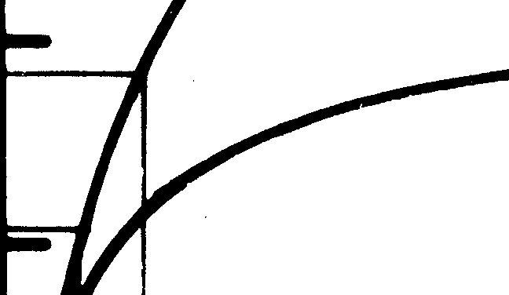0,5
µnm =0,33 and Kn= 1,0 at 20°C and pH=7,2

pH= 7,0 T= 25 °C
pH= 7,0 T= 20 °C
pH= 5,5
T•= 25 °C
pH= 5,5 T= 20 °C

<{
0,4

a::
.J.:..

3:
0

a::
0,3

(!) 0,2

u
u... 0,1

u
1.1..1
a..
en 0,0
0

5
AMMONIA

10 15 20 25
CONCENTRATION ( mg N/ I)

FIGURE 5.5: Diagrammatic representation of Eq. 5.19 - rela- tionship describing the specific growth rate of Nitrosomonas for changes in temperature and mixed liquor pH.

* Alkalinity signifies the Total Alkalinity obtained by titrating the sample to an equivalent carbonic acid solution at pH approximately 4,3.

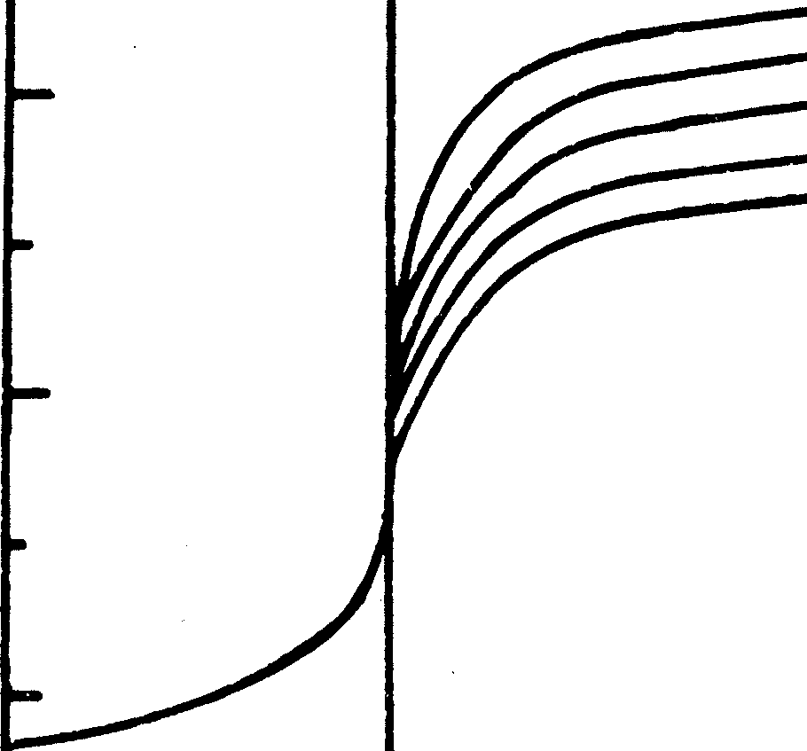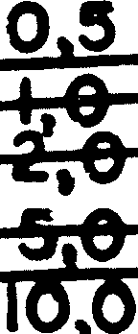ALKALINITY (mg/I as CoC03)
10
l&J
:::>
-'
8
6
:c
a.
• CARBON DIOXIDE _J CONCENTRATION
(mg/I aa Caco3)
er
0
4
SATURATION - O,
0
:::>
fflg/1
aa Caco3
_J
0 2
l&J
)<
2
o.
-100
----+-,----...
0
100
200
. -6
300 400

FIGURE 5.6: Mixed liquor pH versus alkalinity for different concentrations of carbon dioxide.

pie of an influent having an Alkalinity of 200 mg/ f. as CaCO3; expected production of nitrate is 24 mgN/£. The expected Alkalinity in the effluent will be (200- 7,14. 24) = 29 mg/£ as CaCO₃• From Figure 5.6, such an effluent is likely to have a pH< 7,0.
Wastewaters having low Alkalinity are often en­ countered where the municipal supply is drawn from areas underlain with sandstone.
The abovementioned problems are to be expected in aerobic nitrifying plants treating municipal effluents of towns located in the coastal areas of South Africa, from Cape Town to, and including, Natal. The effluent from Somerset West mentioned earlier (see Figure 5.3) is a typical example. The only practical approach to treating such effluents is to create an anoxic zone in the process to denitrify some or all of the nitrate generated. In contrast to nitrification, denitrification takes up hydrogen ions which is equivalent to generating Alkalinity. By considering nitrate as electron acceptor, it can be shown that for every mg (NO₃-N) denitrified, there is an increase of 3,57 mg Alkalinity as CaCO₃• Hence incorporating denitrification in a nitrification pro­ cess causes the net loss of Alkalinity to be reduced usually sufficiently to maintain the Alkalinity above 40 mg/£ and consequently the pH above 7.*
In the example above, where the Alkalinity in the
process is expected to decline to 29 mg/ f. as CaCO₃, if 25% of the nitrate could be denitrified the gain in Alkalinity would be (0,25. 29. 3,57) = 26 mg/ f. as CaCO₃ and will result in an Alkalinity of (29+26)=55 mg/£ as CaCO₃ in the process. In this event the pH should re­ main above 7. For low Alkalinity wastewaters it is im-
perative, therefore, that denitrification be built into nitri­ fying plants.
Incorporation of unaerated zones in the process in­ fluences the sludge age of the process at which nitrifica­ tion takes place so that cognizance must be taken of the effect of an anoxic or unaerated zone in establishing the sludge age of a nitrifying-denitrifying plant.

  - Unaerated zones
The effect of unaerated zones on nitrification can be readily formulated if the following assumptions are made:

- Nitrifiers, being obligate aerobes, can grow only in the aerobic zones of a process.

- Endogenous mass loss of the nitrifiers occurs under both aerobic and unaerated conditions.

- The concentration of nitrifiers in the unaerated and aerated zones is essentially equal.

With these assumptions, Ekama, van Haandel and Marais (1979) showed that if a fraction fxt of the total sludge mass is unaerated, i.e. (1 -fxtl is aerated, the effluent ammonia is given by
N _ Knr!bnr+1/Rs) (5.20)
a - µnmr(1-fxtl-(bnr+1/R5)
Equation 5.20 is identical in structure to Eq. 5.13, if one views the effect of the unaerated mass (fxtl as

*Quantitative estimation of the denitrification that can be achieved in an anoxic-aerobic process is considered in Chapter 6.

reducing the value of µnmT to µnmT ( 1 - fxtl.
Following the same reasoning as that preceding Eq. 5.14 one can show that the minimum sludge age for nitrification Rsm in a process having an unaerated mass fraction, fxt, is
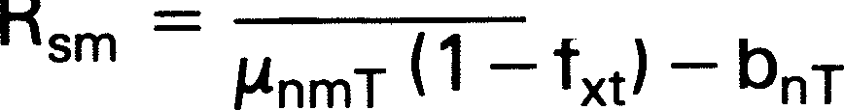
1 (5.21)
Alternatively, if Rs is specified the minimum aerobic sludge mass fraction (1-fxml that must be present for nitrification is found by substituting Rs for Rsm and fxm for fxt in Eq. 5.21 and solving for (1-fxm), i.e.
(1-fxml = (bnT+ 1/Rs)/µnmT (5.22)
or equivalently the maximum allowable unaerated sludge mass fraction is given by solving for fxm in Eq. 5.22,
(5.23)*
For a fixed sludge age, Rs, the design value for the minimum aerobic sludge mass fraction (1-fxml always should be significantly higher than that given by Eq. 5.22, because nitrification becomes unstable when the aerated sludge mass fraction decreases to near the minimum value as given by Eq. 5.22. Consequently to ensure efficient nitrification (>90%) the minimum aerobic sludge mass fraction ( 1 - fxml must be increased by a factor of safety, St to give the minimum design aerobic sludge mass fraction; from Eq. 5.22,
(5.24a)
and the corresponding maximum design unaerated sludge mass fraction, from Eq. 5.23 is
(5.24b)

With the aid of the temperature dependency equa­ tions for nitrification (Eqs. 5.15 and 5.16), a diagram­ matic representation of Eq. 5.24 is given in Figure 5.7 for St= 1,25, µnm20=0,65 and 0,3$/d at 14°C and 20°C. The two µnm2o values are the approximate extremes of the range of µnm₂o values reported in the literature. The diagram shows that fxm is very sensitive to the maxi­ mum specific growth rate of the nitrifiers (µnmT): unless a sufficiently large aerobic sludge mass fraction is pro­ vided (i.e. 1 - fxm, see right hand of Figure 5.7), nitrifica­ tion will not take place and consequently nitrogen removal by denitrification is not possible.
If one fixes the minimum design aerobic sludge mass fraction, the sludge age can be determined by solv­ ing for (1 -fxml in Eq. 5.24a. Knowing Rs the value of the effluent ammonia concentration (N8) can be determined from Eq. 5.20. By doing a number of solutions of this kind, at 14°C, it will become apparent that if St is selected at 1,25 or greater the effluent quality will have stability and range from 2 to 4 mg (NH₃-N)/£ depending on the other constants in the formulations. Accepting the sludge age as determined at 14°C, then at 20°C the

FACTOR OF SAFETY• 1,25
Unmzo •0,65
-------- Unmzo •0,33

FIGURE 5.7: Maximum allowable unaerated sludge mass frac- . tion and minimum aerated sludge mass fraction required to· sustain nitrification versus sludge age for different maximum specific growth rates of the nitrifiers at 20°C and 14°C and
St=1,25.

0,8

*The usual approach for determining fxm is based on the concept of "aerobic sludge age" i.e. equating the minimum sludge age for nitrification Rsm to the aerobic sludge age of the process Rsa, This leads to fxm=1-1/{Rs(µnmT-bnTl}. This equation overestimates the maximum unaerated sludge mass fxm at a particular sludge age because the approach ignores the endogenous mass loss of the nitrifiers in the unaerated zones. If the endogenous mass loss can be ignored in nitrification kinetics i.e. bn = 0,0, then the two approaches are equivalent.

value of St will be found to have increased significantly and the effluent ammonia to have decreased to 2 mg/ l or less. Consequently, for design the lower expected temperature should be selected to determine the sludge age and the aerobic mass fraction. If this is done, using St= 1,25, one can accept an effluent ammonia value of 2-4 mgN/ lat the lowest temperature and 1-3 mgN/ lat 20°C, that is, Eq. 5.20 is bypassed by the approximation above, provided Rs at least equals 1,25 Rsm· This ap­ proximation is sufficient for design and will be the ap­ proach followed in the design example.

    - Maximum allowable unaerated mass traction

The equations above allowed the maximum design unaerated sludge mass fraction to be determined for any selected sludge age (Eq. 5.24b). If one accepts St= 1,25 then fxm or (1 -fxml can be plotted versus R5 for any selected µnmT· This is illustrated in Flgure 5.7 where the design (fxml and (1-fxml values are plotted
versus Rs for 20°C and 14°C for two selected µnm2o reference values of 0,65 and 0,33 (b020 was fixed at 0,04/d). Evidently from Figure 5.7, for J.Lnm₂₀=0,65 the unaerated mass fraction at 14°C can be approximately
0,8 at sludge age of 30 days. Such a high unaerated mass fraction is the indicated one theoreticatly at R₅ = 10 days or longer at 20°C. One may now ask: 1s this mass fraction acceptable for design or are other con­ straints present that may limit the fracti-on to lower values? To answer this, two aspects appear to be perti­ nent:

- Expe.rience with laboratory scale nitrification denitrification plants tends to support the opinion that at high unaerated mass fractions, the process is prone to bulking particularly at low temperatures. Processes at unaerated mass fractions of 0,5 or less show much less tendency in this regard.

- An upper limit to the unaerated mass fraction is evi'­ dent from experimental work on the Ludzack­ Ettinger process, and theoretical predictions using the general acfivated sludge model. Experimentally

From the discussion, above it would appear that the unaerated mass fraction should not be allowed to in­ crease above a certain upper limit of about 50%, but certainly not above 60%, as indicated in Figure 5.7.

In design of N and P removal plants the unaerated sludge mass fraction fxm usually needs to be high Le. 40%. If the µnm20 value is low i.e. <0,40/d {which witl be the usual case in design where insufficient informa­ tion on the µnm20 is available) ,the necessary high fxm magnitudes will be obtained Olf,;IIY at long sludge ages (see Flgure 5.7). For example, if J.Lnm2o=0,35/d, then
with St= 1,3 at Tmin= 14°C, an fxm = 0,45 (Eq. 5.24b)
gives a sludge age of 25 days and for fxm = 0,55 a sludge age of 37 days. Long sludge ages require large process volumes - increasing R₅ from 25 to 37 days increases the process volume by 40% (see Figure 4.3) whereas fxm increased only 22%. Also, for the same P content in the sludge mass, t e P removal is reduced as the sludge age increases because the mass of sludge wasted daily decreases as the sludge age increases (see Figure 4.5). Consequently, for low l'nm2o values, the increase in N and P removal that can be obtained by increasing the unaerated sludge mass fraction above 0,50 to 0,60 might not be economical due to the large process volumes this will require, and might even be counter productive insofar as it affects P removal. A sludge age of 35 days probably is near the limit of eonomic prac­ ticality which, for low µnm₁₄=0,16 values will limit the unaerated mass fraction to about 0,5. At higher µnml4 values, the sludge ages allowing 50 per cent unaerated mass fractions decrease sjgnif.icantly again indicating the advantages of determining experimentally the value of µ0m20 to check whether a higher value is acceptable.

,4.5 Dissolved oxygen concentration
High dissolved oxygen concentrations, up to 33 mgll, do not appear to affect nitrification rates significantly. Low oxygen concentrations however do reduce the nitrification rate. Stenstrom and Poduska (1980) have suggested formulating this effect as follows:
0

at 20°C with Rs =20 days, if fxm >0,70, the mass of sludge generated is found to increase sharply. This observation is indicated also by theoretical simu1a­
/.(no= µnmo ·Ko+ 0
where
{5.25)

ion. Theoretically, this ha_ppens for fxm > 0,60 at T= 14°C and R₅=20 days. The reason is that for such high fxm, the exposure of the sludge to · aerobic conditions becomes insufficient' to utilize the adsorbed and enmeshed particulate material. This le.ads to a decrease .in active mass and oxygen demand and a build-up of enmeshed material, which causes a progressive decline in process ac­ tivity because of the decline in active mass. When this happens, the process stiH functions in that the COO is removed from the wastewater, but the degradation of the COO is reduced; the process begins to assume the role of a contact reactor of a contact-stabilization process, i.e. a bio-flocculator wjth minimal degradation. This critical state occurs at tower fxm as the temperature is decreased and the sludge age is .reduced (Arkley .and Marais,
1.982).
0 = oxygen concentration in butk liquid (mgO/ l) Ko= half saturation constant {mg0/1}
JJ.nmo = maximum specific growth rate :(/d)
Jlno = specific growth rate at O mg/ l oxvgen{ / d}.
The value attributed to K0 has ranged from 0,3 to 2 mgO/l, i.e. at DO values below Ko the growth rate will decfine to less than half the rate where oxygen is present in adequate concentrations.
The wide range of K₀ probably has arisen because the concentration of DO in the bulk liquid is not necessarily the same as inside the b:iologicaJ floe where the oxygen consumption takes place. Consequently the value wiH depend on the size of floe, mixing intensity and oxygen diffusion rate into the floe. Furthermo:re in a ful.1-scale reactor the 00 wlU vary over the reactor volume due to the discrete ,points of ,oxygen input {with mechanical aeration) and the impossibitny of achieving

instantaneous and complete mixing. For these reasons it is not really possible to establish a generally applicable minimum oxygen value - each reactor will have a value specific to the conditions prevailing in it. In nitrifying reactors with bubble aeration a popular DO lower limit, to ensure unimpeded nitrification, is 2 mgO/ £ at the surface of the liquid.
Under cyclic flow and load conditions the dif­ ficulties of ensuring an oxygen supply matching the oxygen demand and a lower limit for the DO have been discussed previously (see Chapter 4, Section 11.3), Equalization of the load probably presents the best prac­ tical means to facilitate control of the oxygen level in the reactor. In the absence of equalization, mitigation of the adverse effects of low oxygen concentration during peak oxygen demand periods is by having sludge ages significantly longer than the minimum necessary for nitrification.

4.6 Cyclic flow and load

It is well attested experimentally that under cyclic flow and load conditions the nitrification efficiency of an ac­ tivated sludge process decreases compared to that under steady conditions. This behaviour is also ap­ parent in simulation studies using the general activated

poses it is not possible to obtain a complete set of values so that one approach is to accept the value of one constant and in any particular experimental evalua­ tion determine the other constants from the experimen­ tal data using this value. The estimates for Yn and Kn ac­ cepted in this monograph are listed in Table 5.1; ex­ perimental µnm determination, therefore, is relative to the value of Yn and Kn listed.

sludge model. From the simulation studies, during the 5. DESIGN CONSIDERATIONS
high flow and/or load period, even though the nitrifiers
are operating at their maximum rate, it is not possible to 5.1 Fate of the influent TKN
oxidize all the ammonia available, and an increased am-
monia concentration is discharged in the effluent. This The various fractions of the influent TKN have been in turn reduces the mass of nitrifiers formed in the pro- described in Chapter 2. Of these the following are of im­ cess - equivalently the effect of cyclicity in flow and portance to our discussion: ( 1) free and saline ammonia load is to reduce the aerobic sludge age. The adverse ef- concentration (N8i); (2) biodegradable organic nitrogen
feet of the cyclicity becomes more marked as the frac- (N0;); and (3) the soluble unbiodegradable organic tional amplitude of the flow and load cycles increase, nitrogen (Nu;l.
and, is ameliorated as the aerobic sludge age increases. The biodegradable organic nitrogen is decomposed Simulation studies of the cyclic effect have !ndicated , in the process by heterotrophic action to free and saline that an approximate relationship can be established be- ammonia, Furthermore, on death of the organisms, by tween the effluent ammonia concentration under steady endogenous mass loss, the nitrogen released is in the state and that under cyclic conditions (see van Haandel organic bound form and the biodegradable fraction also and Marais 1981). However if the factor of safety on is broken down to free and saline ammonia. These two nitrification, St, is 1,25 or greater the cyclic effect is sources of free and saline ammonia together with that in relatively small and for design usually can be neglected· the influent are utilized by the organism mass first for At the risk of being tedious, it should again be the formation of new organisms and the balance for
pointed out that if the value of µnm is selected higher generation of nitrate, if the conditions are favourable.

than the actual value, _even !th a sludge age
o1f ,25 to The 'exact' formulations describing the interactions

1,35 times the theoretical minimum, the plant is hkely to between the free and saline ammonia and the organic give rise to a fluctuating nitrate effluent with redu ed bound nitrogen are complex and can be developed ef­ mean efficiency in nitrif!cation. Hence conservative fectively (at present) only in terms of the growth-death­ estimate of µnm is essential for a safe desig : . . regeneration model of Dold, Ekama and Marais (1981).*
Under cyclic flow and load cond1t1on_s: it_ is However under steady state conditions the kinetics necessary to know the value of both the spec1f1c_ yield simplify and the formulations reduce to describing net coefficient of the Nitrosomonas, Yn, the maximum effects. These can be developed readily in terms of the specific growth rate constant, µnmT, and the half satura- synthesis - endogenous respiration approach already tion constant, Kn; in contrast, only µnmT and Kn are used to develop the steady state equations for car­ necessary in steady state calculations. The values of bonaceous material degradation, in Chapter 4. For these constants have been determined by a variety of design there is even a further simplification possible: In methods but the constants have a conjoined effect that nitrification systems if, for example, the constraints are may cause that in a particular method of evaluation dif- put on the system that the minimum design sludge age ferent sets of values may be obtained. For practical pur- must be at least 1,25 to 1,35 times the theoretical

* A more elaborate discussion is available by van Haandel and Marais (1981).

minimum to initiate nitrification, and, that the pH re­ mains above 7, some of the steady state kinetic equa­ tions predict effluent concentrations that fall within a narrow band of values, sufficiently narrow that one can accept the effluent parameter virtually as constant.* Below are set down some of these steady state equa­ tions of importance in developing design procedures. Simple approximations adequate for design are in­ dicated and some general response graphs are derived. In the design of those aspects of a process effect­
ing nitrification, basically the following information is needed: (1) effluent TKN concentration; and (2) effluent nitrate concentration.

5.2 Effluent TKN

The effluent TKN will consist of free and saline am­ monia (Na), biodegradable soluble organic N (N0), unbiodegradable soluble organic N (Nu) and TKN in the effluent volatile solids. Equations for the fractions are set out below:
- Free and saline ammonia (N8):

Na is given by Eq. 5.20, i.e.
Nui = soluble unbiodegradable organic nitrogen, mg(TKN-N)/1. Its value is given by Eq. 2.12.

All these effluent fractions are soluble; consequently the total soluble TKN in the effluent (Nil is given by the sum of these, i.e.
Ni = Na+ N0 + Nu (filtered Nil (5.28a)
The experimental value of Ni will be given by the TKN of the filtered effluent sample. If the sample is not filtered the theoretical TKN of the effluent will be greater by the concentration of TKN in the volatile solids, i.e.
Niv = Na+N0+Nu+fn.Xvt (unfiltered Nil (5.28b) where
Xvt = effluent volatile solid concentration (mgVSS/£)
fn = fraction of TKN in VSS 0,1 mg(TKN-N)/ mg\t'SS.

5.3 Nitrification capacity

The concentration of nitrate generated in the system ( Ne) is given by the TKN in the influent (Nii) less the

N = Knr(bnr+1/Rs)
a µnmT(1-fxtl-(bnr+1/Rs)
(5.20)
soluble TKN in effluent (Nil less the concentration of total influent TKN incorporated in the net sludge

Note that Na is independent of the influent am­ monia concentration. Note also that the equation applies only if the sludge age Rs > Rsm, however
generated each day (Nsl i.e.
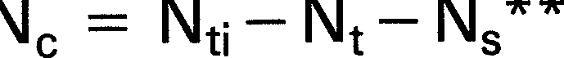

(5.29)

this condition always should be satisfied in design.

- Biodegradable organic nitrogen concentration (N0)
The biodegradable organic nitrogen is broken down to free and saline ammonia by heterotrophic organisms. Although a complex reaction, involving a feedback of this nitrogen form from death of the organisms, the prediction simulated by the gener91 model indicates that the following equation, in terms of the influent biodegradable organic nitrogen concentration, is adequate
N = No; (5.26)
o 1 + K, Xa Rhn
where
N0i = influent biodegradable organic nitrogen mg(TKN-N)/1. Its value is given by Eq. 2.14.
K, = kinetic constant for degradation of N0• Its value and temperature dependency is given in Table 5.3.
Xa = active mass concentration in aerobic reac­
tor.
Rhn = nominal hydraulic retention time in process.
- Soluble unbiodegradable organic nitrogen (Nul

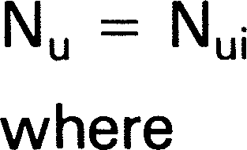
(5.27)
The value of Ns is determined from the mass of nitrogen
incorporated in the volatile solids per day. It is given by fn times the mass of volatile solids wasted per day (M(XJ/Rsl, divided by the mean daily flow, i.e.

N = fn. M(Xvl (see Chapter 4, Section 9). s Rs.O
where
M(Xvl is given by Eq. 4.13.
Note that M(Xvl does not include the volatile mass of nitrifiers as the masses of these, we have stated previously, are negligible.
In Eq. 5.29, Ne defines the nitrification capacity of the process. A formal definition of nitrification capacity ( Ne) is the mass of nitrate produced per unit volume of flow, i.e. mg(NO₃-N)/ £ of flow.
Eq. 5.29 shows that the nitrification capacity (Ne) is the difference between the influent TKN concentration (Ni;l and the sum of the effluent TKN concentration (Nil and the nitrogen required for sludge production (Ns). The effluent TKN concentration (Nil depends on the ef­ ficiency of nitrification. In calculations, with maximum unaerated sludge mass fraction (fxml, (for a selected sludge age), if the factor of safety (St) is selected greater than 1,25 to 1,35 at the lowest expected temperature (Tmin), the efficiency of nitrification always will be high (>90%) and Ni generally will be less than 3 to 4 mgN/ £. Also, with St 1,25 at Tmin, Ni will be vir-



*The same approach also applied in the design equations for carbonaceous material degradation that, provided Rs> 3 days usually one can ac­ cept the filtered biodegradable COD in the influent as zero (see Chapter 4, Section 3.4).
**This equation presumes that no nitrate is present in the influent and this is true, virtually always, for municipal flows in South Africa.

tually independent of both the process configuration and the subdivision of the sludge mass into aerated and unaerated fractions. Consequently, for design Nt usual­ ly need not be calculated explicitly from Eqs. 5.20, 5.26 to 5.28, but can be taken to be approximately 3 to 4 mgN/1 provided that there is reasonable assurance that the actual µnm2ovalue will not be less than the value accepted for design and that there is sufficient aeration capacity so that nitrification is not inhibited by an insuf­ ficient oxygen supply. Accepting the calculated fxm and selected sludge age (Rs) at the lower temperature, then at higher temperatures the nitrification efficiency and the factor of safety (St) both will increase so that at summer temperatures (Tmax), Nt will be lower, approx­ imately 2 mgN/ £.
Dividing Eq. 5.29 by the total influent COD concen­ tration (Sti) yields the nitrification capacity per mgCOD applied to the biological process, Ne/ Sti,
NtfSti: Provided the constraint for efficient nitrification is satisfied at the lowest temperature (Tmin) the TKN in the effluent (Nt) can be assumed at Tmin to be about 4 mgN/ £ i.e. Nt/ S1i will range from 0,005 to 0,01 for Sti ranging from 800 to 400 re­ spectively. At Tmax, Nt 2 mgN/ £.

Ns/ Sti: This ratio gives the TKN concentration in the influent abstracted for sludge produc­ tion. Its value will depend on whether settl­ ed or raw wastewater is being treated, and the sludge age. The ratio, N5/Sti, for this purpose can be read from Figure 4.5, or calculated from Eq. 4.23.

Nt/Sti: This value is obtained by measurement of the TKN and COD of the influent and can

Ne/ Sti = N1/Sti - Nsf Sti - Nt/ Sti where
(5.30)
range. from 0,07 for unsettled municipal waste flows to 0,12 for settled flows.

Ne/ S1i = nitrification capacity per mgCOD applied to the process (mgN/mgCOD)
Nt/Sti = TKN/COD ratio of the wastewater
Ns/ Sti = nitrogen required for sludge production per mgCOD applied (see Eq. 4.23).

In Eq. 5.30 the nitrification capacity/COD ratio (Ne/Sti) of a process can be estimated approximately by evaluat­ ing each of the terms in the RHS of the equation as follows:
A graphical exposition of the relative importance of these three ratios on Ne/Sti is obtained by plotting Ne/ Sti versus sludge age for selected influent TKN/COD (Nt/Sti) ratios ranging from 0,07 to 0,09 for raw wastewater and O,09 to O,11 for settled wastewater. The Ne/ Sti values were found from Figure 4.5 (or Eq. 4.23) and the Nt/ Sti values selected constant at 0,007 (this is for Sti of approximately 600 mgCOD/£). The plots for 14°C and 20°C are shown in Figures 5.8a and
5.8b respectively. Also shown plotted on the diagrams are the minimum sludge ages for unaerated mass frac­ tions of 0,0, 0,2, 0,4 and 0,5, at a selected µnm₂ovalue of

0,15
C

TEMP• 14•c

WASTEWATE

fup fu,
0,15
TEMP• 20 •c WASTEWAT f,Jp fu,

0u Unm20
= 0,4 /d CHARACTERISTICS
Unm20 • 0,4 /d CHARACTERISTICS

r bn2o = 0,04 /d RAW 0,13 O,Ol5
8 bn2o • 0,04 /d RAW 0,13 O,Ol5

'z
r
-0,10
>-
Iu-
<ul:
0,05

u
s, • 1,25
SETTLED 0,04 0,08

SETTLED TKNICOD WASTEWATfRl RATIO

RAW WASTEWAT

0
N
0
!j
ur
' z 0,10
>-
Iu-
rf.
cut
z0,05
0
I=
cut
Sf • 1,25
SETTLED o,04 o,oe

SETTLED
WASTEWATER

RAW WASTEWATER

LL
ii:
!::
0
II)
!8
-o 0
Li:
0::
I-

z 0/X)_
0
zooo
5 10 15 20 25 :30 , 0 5 10 15 20 25 :30

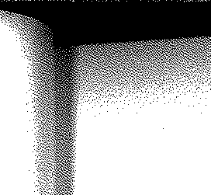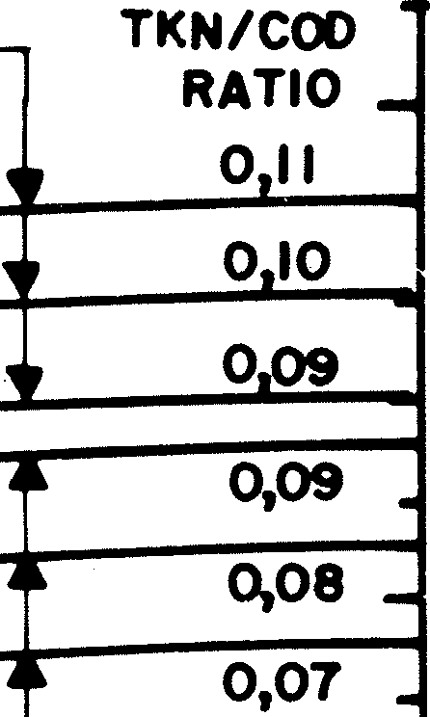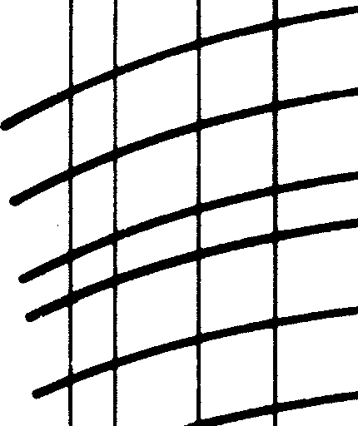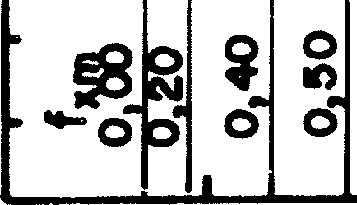SLUDGE AGE (d) SLUDGE AGE (d)
FIGURES.Sa FIGURES.Sb
FIGURE 5.8: Nitrification capacity per mg COD applied versus sludge age for different influent TKN/COD ratios at 14°C (Figure 5.Sa) and 20°C (Figure 5.Sb). Also shown are the minimum sludge ages required to obtain complete nitrification at different unaerated sludge mass fractions for µnm20=0,40/d.

0,4. For any particular unaerated mass fraction the plot­ ted values of Nc/Sti are valid only at sludge ages greater than the corresponding minimum sludge age. These plots allow one to assess the effects of the three ratios and temperature versus sludge age.
Considering the effects of temperature, to obtain complete nitrification at 14°C (for a selected fxml, the sludge age required is more than double that at 20°C. The corresponding nitrification capacities per influent COD at 14°C show a marginal reduction to those at 20°C (because the sludge production at 14°C is slightly higher than at 20°C).
Considering the effect of sludge age for a selected Nt/Sti value, the Ncf Sti increases as the sludge age in­ creases because the nitrogen needed for sludge produc­ tion decreases with sludge age and thus becomes available for nitrification. However, the increase is marginal for Rs> 10 days.
Considering the influent TKN/COD ratio (Nt;IS1i) evidently for both settled and unsettled wastewater, at any selected sludge age, Nc/S1i is very sensitive to the N1;/S1i value; an increase of 0,01 in N1;/S1; causes an in­ crease of about 0,01 in Nc/S1; (0,01 mgN/mgCOD). For the same N1;/ S1; ratio for raw or settled wastewater (compare TKN/COD ratio of 0,09 in Figures 5.8a and b), Nc/S₁; for unsettled is less than for settled wastewater because more volatile solids are produced per unit COD load from unsettled than from settled wastewater; however, leaving aside this point of difference, the in­ crease in nitrate produced per influent COD will, when the influent TKN/COD ratio increases, increase the dif­ ficulties, or, make it impossible, to obtain complete denitrification. This will become clear when denitrifica­ tion is considered in Chapter 6. As primary settling in­ creases the influent TKN/COD ratio difficulties in ob­ taining adequate denitrification are always greater with settled than unsettled wastewater; however, because
TABLE 5.2 RAW AND SETTLED WASTEWATER CHARACTERISTICS FOR NITRIFICATION (SEE ALSO TABLES 4.3 AND 6.1)
Parameter
Symbol
Value
Raw
Settled
Units
*See Chapter 3, Section 8. Note that settled wastewater characteristics must be selected so that they are consistent with primary sedimentation tank behaviour and the raw wastewater characteristics.
primary settling removes COD, then for the same flow, the mass of volatile solids and the oxygen demand in the biological process will be lower for settled than for raw wastewater thereby giving rise to savings in plant volume and oxygenation costs.

- DESIGN EXAMPLE

Design of a nitrification process without denitrification will be considered. When denitrification is required con­ straints additional to those imposed by nitrification must be applied and these cannot be incorporated in the design until the theory of denitrification is dealt with.
For the purpose of constructive comparison the nitrifying activated sludge plant will be designed for the same waste flows and characteristics as that accepted for the design of a process for carbonaceous material removal (see Chapter 4, Section 12). The wastewater characteristics, for raw and settled wastewaters are listed in Table 4.3 and the additional characteristics needed for nitrification are listed in Table 5.2.

  - Effect of nitrification on mixed liquor pH

An important initial consideration is the possible effect of mixed liquor pH on the µnm2o value. In Section 4.3 above it was stated that nitrification consumes alkalinity
- 7,14 mg/£ as CaCO₃ for every 1 mgN/ £ ammonia converted to nitrate - and if there is insufficient alkalinity in the influent, the mixed liquor pH is depress­ ed below 7,0 causing a reduction in the µnm2o value (see Eq 5.17).
The influent TKN/COD ratio of the raw wastewater is 0,08 mgN/mgCOD (see Tables 4.3 and 5.2). With a relatively low µnm₂o value of 0,36/d, the sludge age needs to be 10 days or longer to ensure nitrification

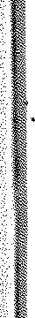

Influent TKN concentration | N1; | 48 | 41 | mgN/1
Influent TKN/COD ratio |  | 0,080 | 0,114 | mgN/mgCOD
Ammonia fraction of TKN | fna | 0,75* | 0,83* | mgN/mgN
Unbiodegradable soluble organic N fraction | fnu | 0,03* | 0,04* | mgN/mgN
Nitrogen fraction of volatile solids in influent | fn | 0,10 | 0,10 | mgN/mgVSS
pH of wastewater |  | 7,5 | 7,5
Total alkalinity | alk | 200 | 200 | mg!J. as CaCO₃
Maximum specific growth rate of nitrifiers | µnm20 | 0,36 | 0,36 | Id.
Influent flow | Q | 13,3 | 13,3 | Ml/d

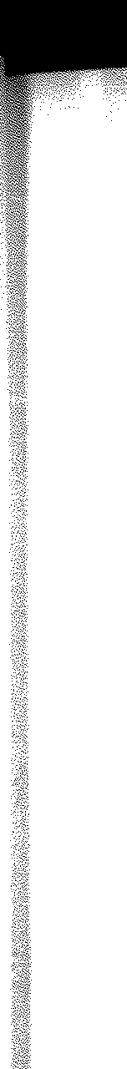(St= 1,3) at a minimum temperature of 14°C in a purely aerobic process (fxm = 0,0) (see Eq. 5.24). At this sludge age the nitrification capacity is about 0,05 mgN/mgCOD for a TKN/COD ratio of 0,08 mgN/mgCOD, (see Figure 5.8a). Hence the nitrate concentration produced (per J, influent) should be about=O,O5.60O=3O mgN/£. This will cause an alkalinity reduction of 7,14. 30 = 214 mg/J, as CaC0₃• Because the influent alkalinity is only 200 mg/ J, as CaC0₃, the mixed liquor alkalinity will drop below 40 mg/ J, as CaC0₃ causing the mixed liquor pH value to drop below 7 (see Figure 5.6). The low mixed li­ quor pH value will cause unstable and incomplete nitrification (see Section 4.3 above) and produce an ag­ gressive water (which over a few years can cause con­ siderable damage to the concrete surfaces of the treat­ ment works) and can be the cause of bulking sludges and high solids content in the settling tank effluent due to denitrification action in the secondary settling tank.
The simple approximate calculation above, therefore, can make the designer aware, at an early stage of possible adverse consequences to be expected from a proposed design. In the instance above the designer should give consideration to a nitrification­ denitrification process, to recover some of the alkalinity loss due to nitrification, thereby to maintain the pH, reduce the possibility of bulking and eliminate (usually) rising sludge problems in the settling tank. (See Chapter 6, Section 1.4). In general a high TKN/COD ratio coupl­ ed with low alkalinity in the influent are reliable in­ dicators warning of problems to be expected in aerobic nitrifying processes.

  - Minimum sludge age for nitrification

For the purposes of demonstrating nitrification under purely aerobic conditions, it will be accepted that the in­ fluent alkalinity is sufficiently high to maintain an ef­ fluent Alkalinity above 40 mg/ J, as CaC0₃• Hence no adjustment to µnm2o and Kn2o for pH needs to be made , as the pH is assumed to remain above 7,2. The adjust­ ment of the kinetic constants of nitrification for temperature is given in Table 5.3.
For a completely aerobic process i.e. fxm=O, with µnm20 = 0,36/ d and St= 1,3, the minimum sludge age for nitrification (R5m) is found from Eq. 5.24 i.e.
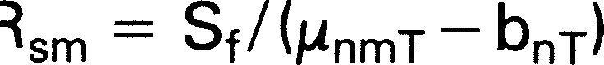

= 3,2 days at 22°c (2,5 days with St= 0,0)

= 8,9 days at 14°C (7,5,days with St=O,O)

Clearly, to ensure nitrification th'roughout the year for the relatively low µnm2o value of O,36/d, the sludge age of a purely aerobic process should be about 10 to 12 days.

  - Raw wastewater

The influent TKN concentration of the raw wastewater is 48 mgN/ £ (see Table 5.2 for wastewater character­ istics). Accepting an ammonia fraction of the influent TKN (fnal of 0,75* and an unbiodegradable soluble organic nitrogen fraction (fnul of 0,03* for the raw sewage (from Table 5.2), gives the influent ammonia concentration (Nail (from Eq. 2.11) as
Nai = 0,75.48 = 36 mgN/ J,
and the unbiodegradable soluble organic nitrogen con­ centration (Nui), (from Eq. 2.12) as
Nui = 0,03.48 = 1,50 mgN/J,.
Accepting the nitrogen content of the volatile solids in the influent (fn) as 0,10 mgN/mgVSS (see Table 5.2), then (from Eq. 2.13) the nitrogen concentration associated with the unbiodegradable particulate COD (Npi) is
Npi = 0,10 (0,13.600)/1,48 = 5,3 mgN/J,.
Hence (from Eq. 2.14), the biodegradable organic nitrogen concentration in the influent which can be con­ verted to ammonia ( N0i) is
N0i = 48 (1-0,75-0,03)-5,3 = 5,3 mgN/1.

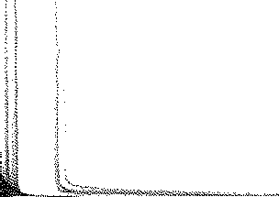

TABLE 5.3 ADJUSTMENT OF KINETIC CONSTANTS OF NITRIFICATION FOR TEMPERATURE
Constant | Symbol | 20°c | e | 14°c | 22°c | Eq, No,
Max, specific growth rate | µnm20 | 0,36 | 1,123 | 0,180 | 0,454 | 5.15a
Saturation coefficient | Kn20 | 1,0 | 1,123 | 0,50 | 1,26 | 5.15b
Endogenous respiration rate | bn20 | 0,04 | 1,029 | 0,034 | 0,042 | 5.16
Organic N conversion rate | K, | 0,015 | 1,029 | 0,013 | 0,016 | 5.31

*The actual choice of these values makes relatively little difference to the final results of the nitrification calculations: in the case of the former (fnal, most of the organic nitrogen is converted to ammnnia in the process and in the case of the latter (fnul, this value merely increases the ef­ fluent TKN concentration by a fixed value.

  - Settled wastewater

Following the above procedure for settled wastewater,
i.e. fna=0,83, fnu=0,04 (see Table 5.2) yields the following:
For Rs > Rsm: '
From Eq 5.13, the effluent ammonia concentration is given by
Nae = KnT(bnT + 1/Rs)/ {µnmT- (bnT + 1/Rs)} (5.35a)

N1; = 41,0

Na; = 0,83.41,0
= 41,0 mgN/£

= 34,0 mgN/ £
Hence the effluent TKN concentration (N1el is
N₁e= Nae+N₀e+Nue (mgN/£) (5.36a) and the effluent nitrate concentration (Nnel is

Nu;= 0,04.41,6
1,50 mgN/£
Nne = N ; - Nte
{mgN/£)

Np;= 0,10 (0,04.360)/1,48 = 1,0 mgN/£
= Nti - Ns - Nte
(from Eq. 5.34) (5.37a)

N0; = 41,0-34,0-1,5-1,0 = 4,5 mgN/£

  - Nitrification process behaviour
Analogous to the concentration of active heterotrophic organisms (see Eq. 4.10), the nitrifier organism mass is given by
M(Xnl = M(Nnel YnRs/(1 +bnTRsl (mgVSS)
(5.38a)

For any sludge age longer than about 2 days the effluent biodegradable organic nitrogen concentration (N0el is given (from Eq. 5.26)
i\10e* = N0;/(1+ K,TXaRhn) (mgN/ £l where from Eq. 4.9a, RhnXa = M(Xal/O. Hence
N0e = N0;/(1+K,TM(Xal/O) (mgN/£) (5.31)
From Eq 5.27, the unbiodegradable organic nitrogen in the effluent is
Nue =Nu;= 1,50 mgN/ £ for raw and settled waste- water (5.32)
The nitrogen required for sludge production ( Nsl is
where
M(Nnel = mass of nitrate generated per day
= Q. Nne
where Nne is given by Eq. (5.37a).
The oxygen demand for nitrification is simply 4,57 mgO/mgN times the mass of nitrate produced per day, i.e.
M(Onl = 4,57 M(Nnel (mgO/d) (5.39a)
For Rs< Rsm:
For Rs < Rsm, no nitrification takes place. Hence the effluent nitrate concentration is zero i.e.

given by Eq 4.23 i.e.

Ns =f n{(1-fus-fuplYh(1+fb R )+tio}s- (5.33)
Nne = 0,00 (mgN/£)
The effluent ammonia concentration is
(5.37b)

(1 + bhTRs) hT s fcv t,
The influent TKN concentration available for nitrifica­ tion (N ;l is the difference between the total TKN con­ centration in the influent (N1;) and that required for
Nae = N ; - Noe - Nue
= N1; - Ns - Noe - Nue
(mgN/£)
(from Eq. 5.34)
(5.35b)

sludge production (Nsl (from Eq. 5.19)

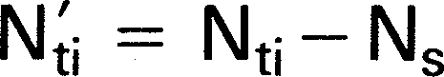

(5.34)
The effluent TKN concentration is

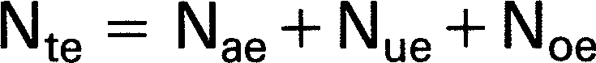

(5.36b)

If the sludge age of the process is longer than the
The nitrifier sludge mass and the nitrification oxygen demand are zero, i.e.

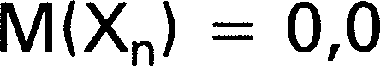
minimum required for nitrification (Rs > Rsm for
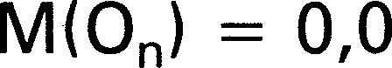
St= 1,00, Eq. 5.14), the TKN concentration available for nitrification will be partially or almost wholly nitrified to nitrate and the effluent nitrate concentration ( Nnel is the
(mgVSS)

(mgO/d)
(5.38b)

(5.39b)

difference between the nitrogen available for nitrifica­ tion (N ;, Eq. 5.34) and the effluent TKN concentration
(N1el· If Rs < Rsm, no nitrification takes place; the ef­
fluent nitrate concentration (Nnel is zero and the ef­ fluent ammonia concentration ( Nael is equal to the nitrogen available for nitrification (N ;, Eq. 5.34) minus the sum of the unbiodegradable and biodegradable TKN
concentrations in the effluent (Nue + N0el. For both Rs < Rsm and Rs > Rsm, the effluent TKN concentration ( N10) is the sum of effluent unbiodegradable and
biodegradable organic nitrogen concentrations (Nue and N00 respectively) and the effluent ammonia concentra­ tion (Nael.
Substituting the respective influent nitrogen con­ centrations for raw and settled wastewaters and the values of the kinetic constants at 14°C into Eqs. 5.31 to
5.39 and plotting the results at different sludge ages yields Figure 5.9. In Figure 5.9a, the different concen­ trations of nitrogen in the process versus sludge age for raw and settled wastewater at 14°C are shown. In Figure 5.9b the nitrifier sludge mass and nitrification oxygen demand for raw and settled wastewater at 14°C are shown. Also shown in Figure 5.9b are the car­ bonaceous and total oxygen demands for raw and settl­ ed wastewater at 14°C. The calculations were repeated for 22°C and are shown in Figure 5.10a and b.

*The subscript e used here and later refers to the effluent. However, N0 = Noe, Na= Nae, etc. because completely mixed conditions are assumed.

! 60 TEMPERATURE• 14°C ; pH=7,5
-- RAW WASTEWATER
R -----·SETTLED WAS?EWATER
_ | INFLUENT TKN Nu
Nue• 1,11 moN/1
Nt• • Nae + Noe + Nue
N--ae- -------- _N --

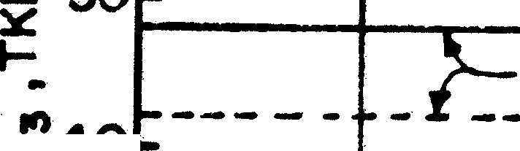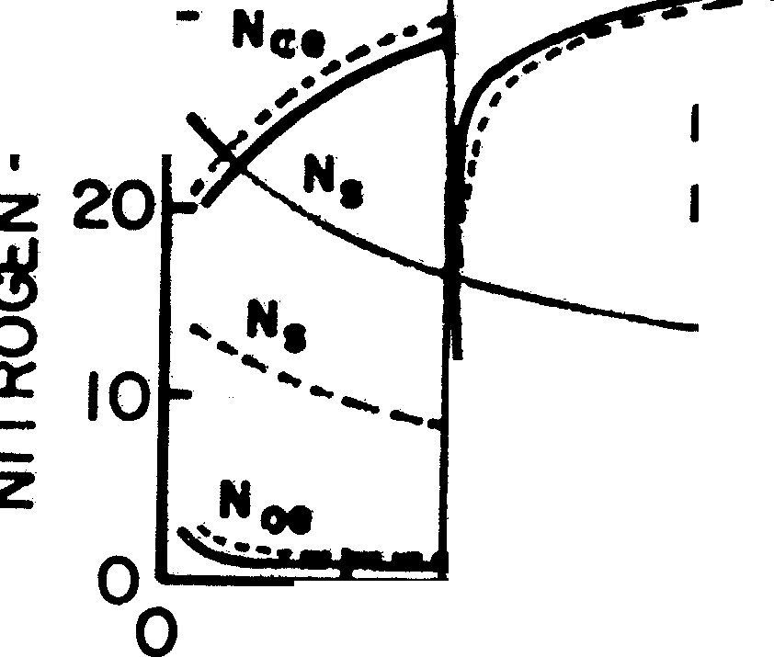E

'zcf40
•-:r.•30

z

:;; 60'.X)
.....
0
5CXX)

z

2cm
►
X
0

------· O-c -
....
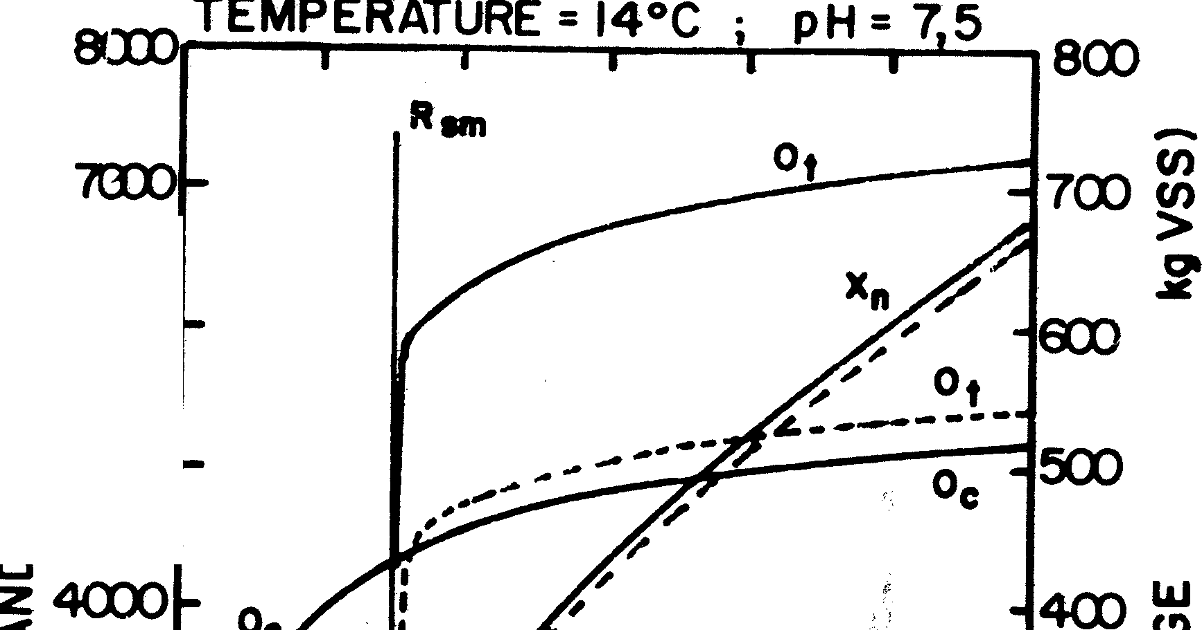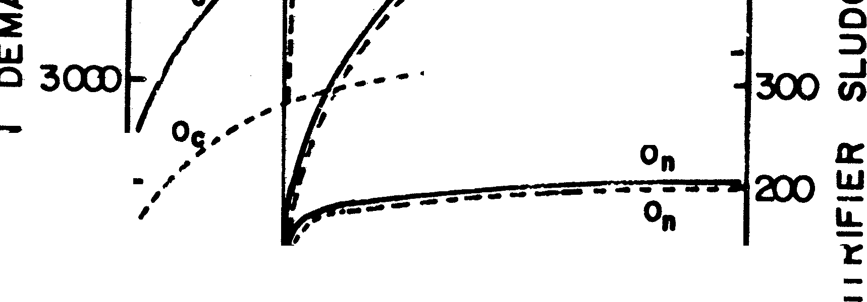(/)
(/)
<[
::IE

ICXD -- RAW WASTEWATER
----SETTlED
ICD z

5 10 15 20 25 30
5 10 15
20 25

SWDGE AGE (d) FIGURE5.9a
SLUDGE AGE ( d)
FIGURE5.9b

FIGURE 5.9: Effluent ammonia INael, organic nitrogen (Noel, and nitrate (N.;8) concentrations and nitrogen required for sludge production INsl (Figure 5.9a). carbonaceous IOcl, nitrification IOnl, and total ((>ti oxygen demand and the nitrifier sludge mass IXnl (Figure 5.9b) versus sludge age for raw and settled wastewater at 14°C.

8<XD TEMPERATLRE • 22°C ; pH•7,5 ax>
Rim
- '700)

(/)
-
(/)

TEMPERATURE• 22°C; pH•7,5
60
r
 |  | -- | RAW WASTEWATER
 | ---•-·SETTLED WASTEWATER
 |  | ---IN-FL-U-E-N-T -T-K-N---Nt-1 -----
Nu•• I,II mo NII
Nt• • Na,+ Moe+ Nu,
10

...6.. (XX)
0
>
..a..,

.... !50

z
le
,I-.;;40
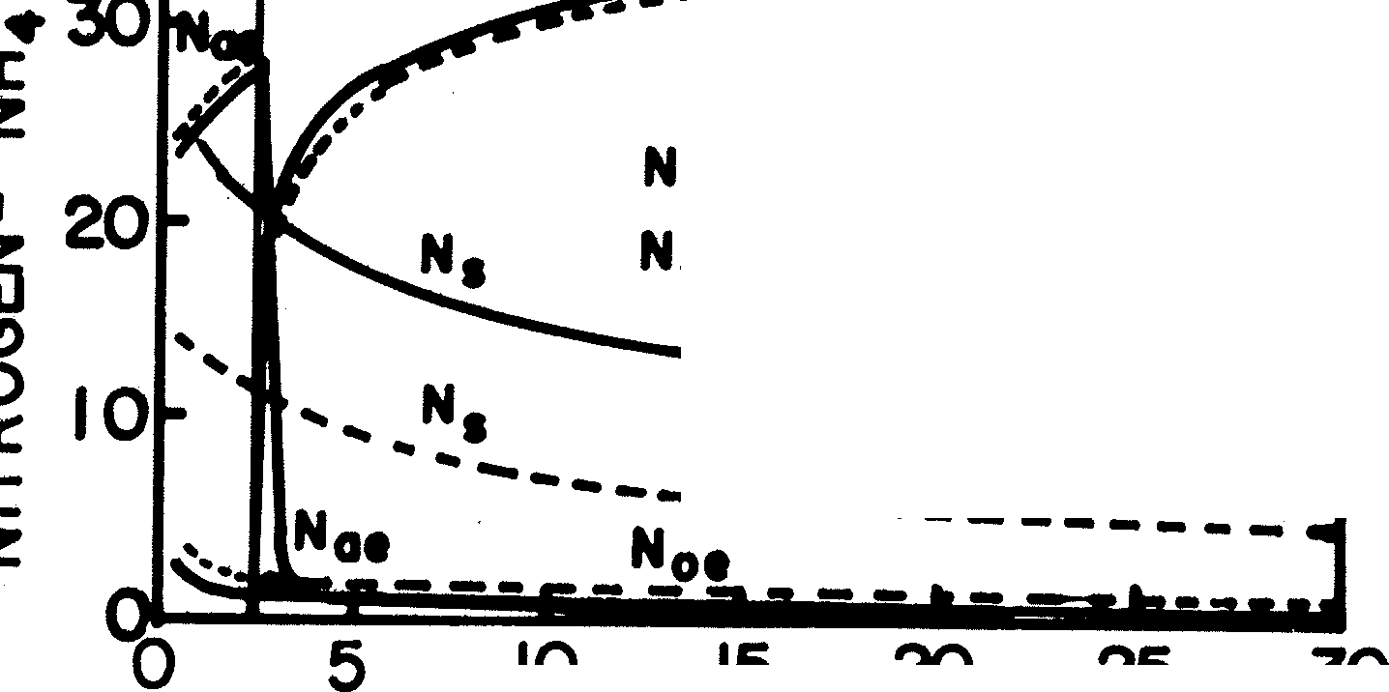
0z
go

0

i4
::E

ffi
t,
►_{X}
0

------ ------
------ -0
C
-- RAW WAS1EWATER
- SETTLED WASTEW«IBI

100

IL.
a::
I-

z

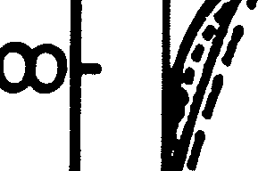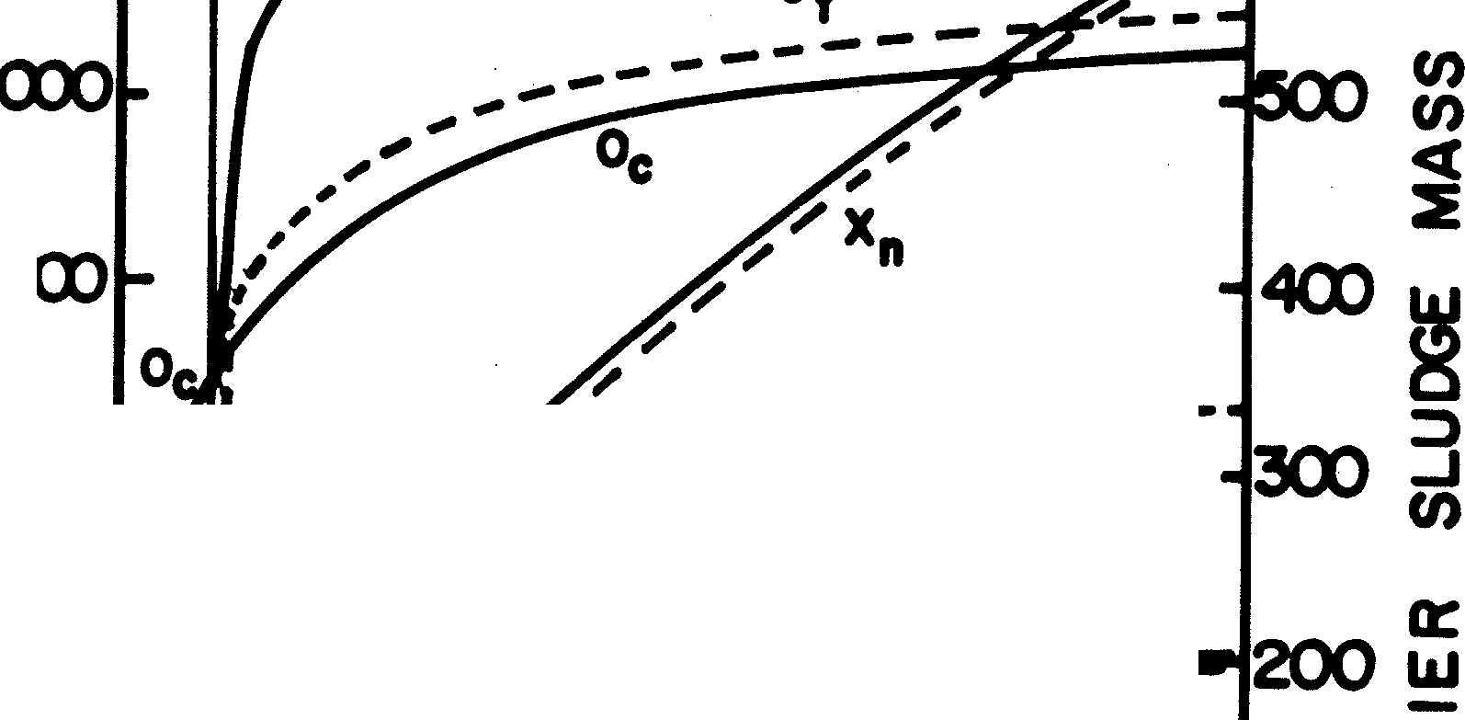
5 10 15 20 25
SLUDGE AGE ( d ) SLUDGE AGE ·(d)
FIGURE 5.10a FIGURE5.10b

FIGURE 5.10: Effluent ammonia (N88), organic nitrogen (N08), andnitrate INnel concentrations. nitrogen required for sludge production INsl (figure 5.10a) carbonaceous IOcl, nitrification IOnl, and total IOtl oxygen demand and the nitrifier sludge mass IXnl (Figure 5.10b) versus sludge age for raw and settled wastewater at 22°C.

Figures 5.9 and 5.10 show that once the sludge age is approximately 25 per cent longer than the minimum required for nitrification, nitrification is complete and comparing the results for raw and settled wastewater, there is little difference between the nitrification oxygen demand and the concentrations of ammonia, nitrate and TKN in the effluent. The reasons for this similar behaviour are: (1) the primary settling tank removes only a small fraction of the influent nitrogen*; and (2) settled wastewater results in lower sludge production, so that the nitrogen available for nitrification in raw and settled wastewater are approximately equal. Tempera­ ture has little effect on the different concentrations of nitrogen. However, a change in temperature causes a significant change in the minimum sludge age for nitrification.
Considering Figures 5.9a and 5.10a, the effluent organic nitrogen concentration ( N0e) is less than 2 mgN/1 for all sludge ages greater than about 3 days. For sludge ages about 25 per cent longer than the minimum for nitrification, the effluent ammonia con­ centration (Nae) is less than 1 mgN/1 so that for Rs > 1,25 Rsm the effluent TKN concentration can be taken to be approximately 4 mgN/ 1. The increase in nitrate concentration (Nn0) with increase in sludge age is principally attributable to the reduction in the nitrogen required for sludge production (Ns). This is important for nutrient removal plants as it indicates that increasing the sludge age of a process, increases the nitrification capacity (see section 5.2 above) even though the ef­ fluent TKN concentration remains constant at about
4 mgN/1 (see Figure 5.8). For Rs < Rsm, the effluent
ammonia concentration (Nae) and hence the effluent TKN concentration (Ntel, increases with increasing sludge age up to Rsm because Ns reduces for increases in Rs.
Figures 5.9b and 5.10b show that the nitrification
oxygen demand increases rapidly once Rs > Rsm but if Rs > 1,25 Rsm, the increase is marginal irrespective of the temperature or wastewater type, i.e. between sludge ages 10 and 30 days about 2000 kgO/d are re­ quired for nitrification. This nitrification oxygen demand represents an increase of 40% and 60% respectively** above the carbonaceous oxygen demand for the raw and settled wastewater. However, the total oxygen de­ mand for treating settled wastewater is only 75% of that for treating raw wastewater.
In order that nitrification can proceed without in­ hibition by oxygen limitation, it is important that the aeration equipment is adequately designed to supply the total oxygen demand; generally heterotrophic organism growth takes precedence over nitrifier growth when oxygen supply becomes insufficient. This is because heterotrophic organisms can grow adequately with dissolved oxygen concentrations of 0,5 to 1,0 mgO/1 whereas nitrifiers require a minimum con­ centration of 1 to 2 mgO /1.
The nitrifiers sludge mass given in Figures 5.9b and
5.10b shows a rapid increase once Rs> Rsm and is ap-
proximately the same for raw or settled sewage, but is slightly higher at 14°C than at 22°C. Comparing the nitrifier sludge mass to the heterotrophic sludge mass, even at high TKN/COD ratios, the nitrifier sludge mass comprises only about 2 per cent of total volatile mass and may be neglected in the determination of the volatile solids concentration in the activated sludge pro­ cess treating domestic wastewaters.
It is worth repeating that primary sedimentation removes only a minor fraction of the TKN but a signifi­ cant fraction of COD. Even th'ough the settled waste­ water has a lower TKN than the raw wastewater the process effluent nitrate concentration will not reflect this difference because the nitrogen removed for sludge production is lower for settled than for raw wastewater. Consequently the nitrate generated is approximately the same for both waste flows. In contrast, the maximum denitrification possible (denitrification potential) in the process is dependent principally on the influent COD concentration and this concentration, we have seen, is significantly reduced by primary sedimentation. This may result in a situation where it may be possible to ob­ tain complete nitrate removal when treating raw waste­ water but highly unlikely when treating settled waste­ water. This difference in removal can have a profound effect on the process design for biological excess phosphorus removal.

9. REFERENCES

ARKLEY, M. and MARAIS, G.v.R. (1982) Effect of the anoxic sludge mass fraction on the activated sludge process. Research Report No W 38, Dept. of Civil Eng., Univ. of Cape Town.
DOLD, P.L., EKAMA, G.A. and MARAIS, G.v.R. (1980) A general
model for the activated sludge process. Prag. Wat. Tech., 12,
47-77.
DOWNING, A.L., PAINTER, H.A. and KNOWLES, G. (1964)
Nitrification in the Activated Sludge Process, J. Proc. Inst. Sew/Purif., 64, 2, 130-158.
EKAMA, G.A., VAN HAANDEL, A.C. and MARAIS G.v.R. (1979)
The present status of research on nitrogen removal: a model for the modified activated sludge process. Presented at the Sym­ posium on nutrient removal, SA Branch of the IWPC, Pretoria, May 1979. Proc. published by Water Research Commission of South Africa.
HERBERT, D. (1958) Recent progress in microbiology. VII. Interna­ tional congress on microbiology. Ed. by Tunevall, Alinquist and Wiksell, Stockholm, 1958, 381-396.
LOEWENTHAL, R.E. and MARAIS, G.v.R. (1977) Carbonate
chemistry of aquatic systems: Theory and application. Ann Arbor Science, Michigan, USA.
LOVELESS, J.E. and PAINTER, H.A. (1968) The influence of metal ion concentration and pH value in the growth of a Nitrosomonas strain isolated from activated sludge. J. Gen. Micro., 52, 1-14.
MALAN, W.N. and GOUWS, E.P. (1966) Geaktiveerde slyk vir riool­ watersuiwering op Bellville. Research Report, Council for Scien­ tific and Industrial Research, Nov. 1966.
MONOD, J. (1950) Technique of continuous culture - Theory and application, (Translation from French), Ann. Inst. Pasteur, 79, 167.
NEYTZEL-DE WILDE, F.G. (1977) Treatment of effluents from am­ monia plants - Part 1. Biological nitrification of an inorganic ef­ fluent from a nitrogen-chemicals complex. Water S.A., 3(3) 113-122.

*This depends on the state of the sewage; if the sewage is "fresh" a larger fraction of the TKN can still be in particulate proteinaceous form.
**Roughly for Rs > 1,25 Rsm, the increase in the total oxygen demand due to nitrification is given by M(O1) = (1 + 5 fnslM(Ocl where fns is the TKN/COD ratio of the wastewater. For processes including denitrification see Chapter 6, Section 7.6.2.

5-17

STENSTROM, M.K. and PODUSKA, R.A. (1980) The effect of
dissolved oxygen concentration on nitrification. Wat. Research,
14, 6, 643-649.

VAN HAANDEL, A.C. and MARAIS, G.v.R. (1981) Nitrification and denitrification in the activated sludge process. Research Report W 42, Dept. of Civil Eng., Univ. of Cape Town.

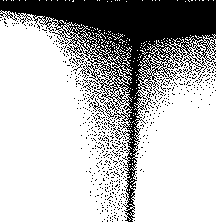

I

5-18

